TASK | Used to protect workpieces, tables, jigs and fixtures from weld spatter build up.
LOCATION OF USE | Workshop |  | Assessment  No |  | 001
PRODUCT NAME | Super Anti-Spatter Spray (non-flammable silicon free) |  |  |  | 001
DESCRIPTION OF SUBSTANCE | Aerosol |  |  |  | 001
MANUFACTURER | Abicor Binzel |  |  |  | 001
MANUFACTURERS CONTACT | Alexander Binzel Schweißtechnik GmbH & Co. KG Postfach 10 01 53 / D- 35331 Gießen, Germany  +49 (0) 6408/59-0  +49 (0) 6408/59-0  technischedokumentation@binzel-abicor.com  Emergency Number: Tel.: +49 (0) 6131 19240 |  |  |  | 001
ASSESSOR | Martin Monaghan CMIOSH |  | Date |  | 23 07 24
TITLE | Health and Safety Consultant |  | Review by |  | 23 07 26
Personnel Performing Task  (Please list below)  Technicians/ Fitters/ Workshop Operatives |  | Time Spent  (Minutes/day)  As and when required, amounting to a few minutes per day | Training Given 
 |  |  | Yes

MSDS Revision Date | Hazard Statement
09/05/2017 | H229 Pressurised Container: may burst if heated  H319 Causes serious eye irritation  Heating increases pressure and risk of burning

Assessment to be conducted in Association with Hazard Data Sheets, a full current copy of which must be attached to this assessment.

Please denote the hazardous properties of the substances used in the task with a

NEW INTERNATIONAL GLOBALLY HARMONISED HAZARD SYMBOLS
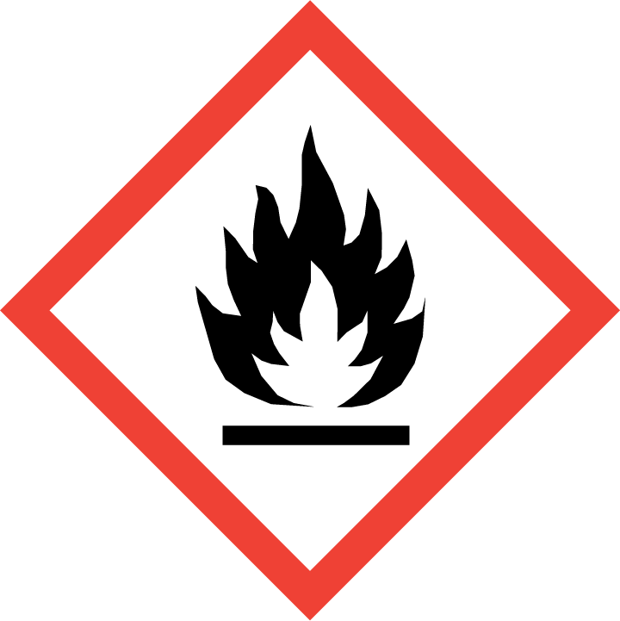 | 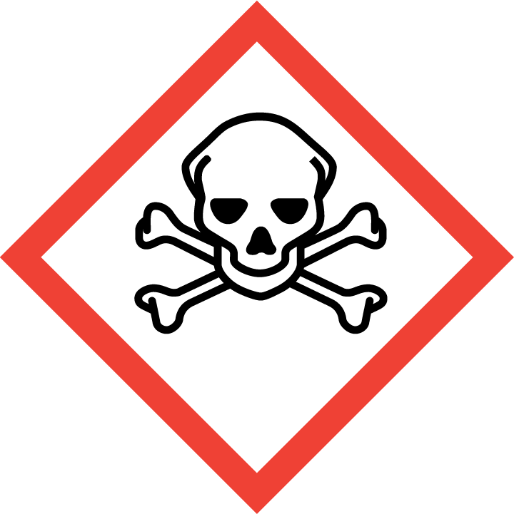 | 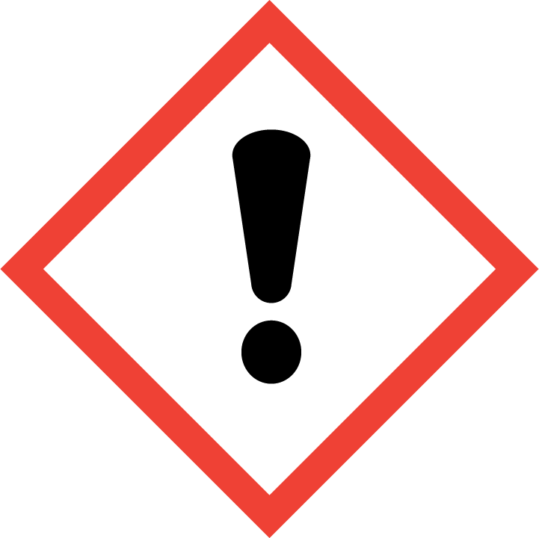 | 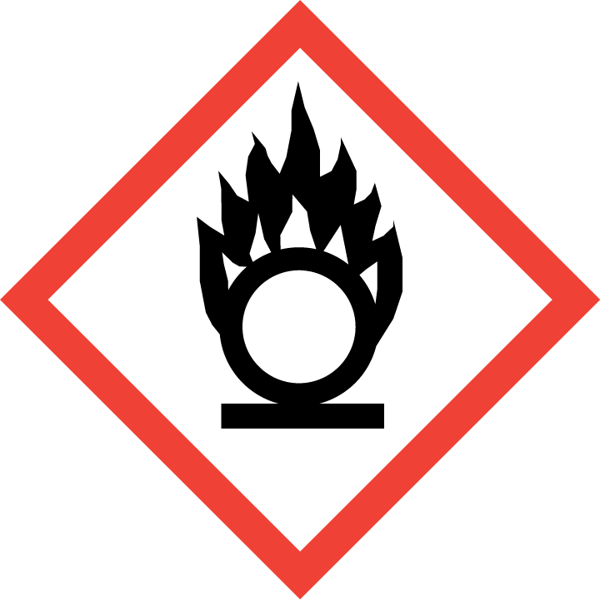 | 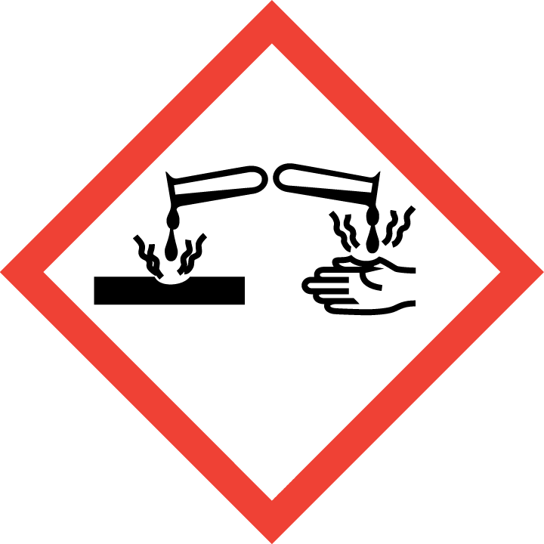 | 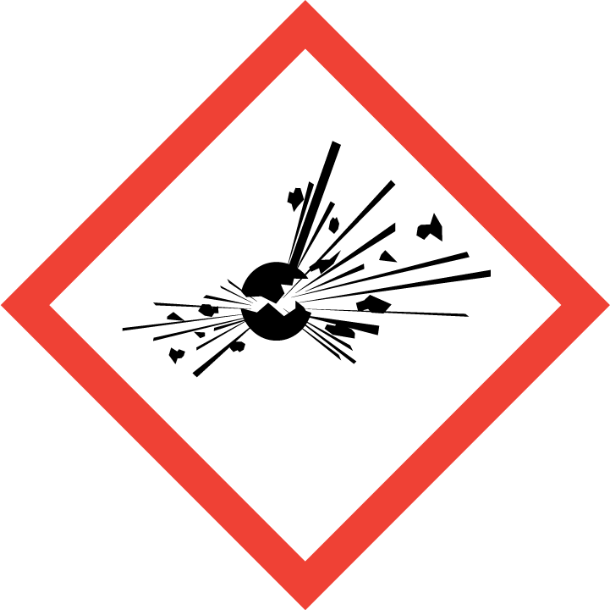 | 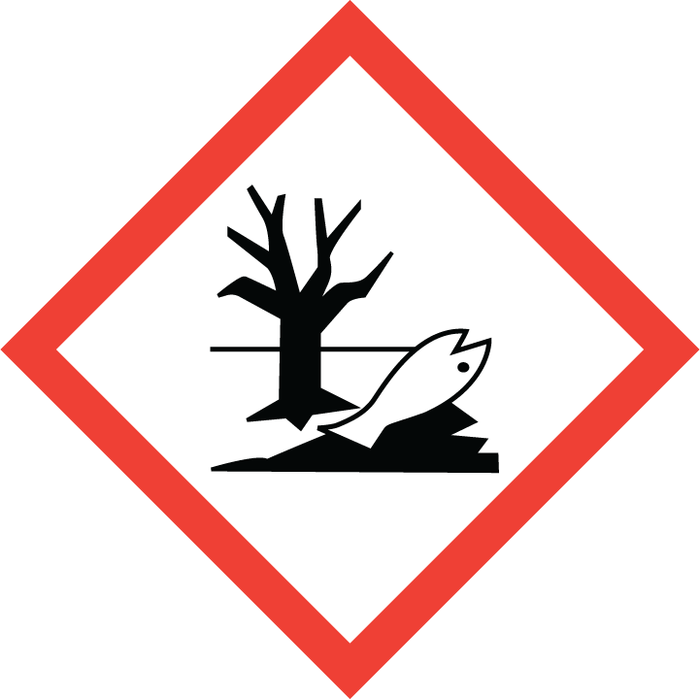 | 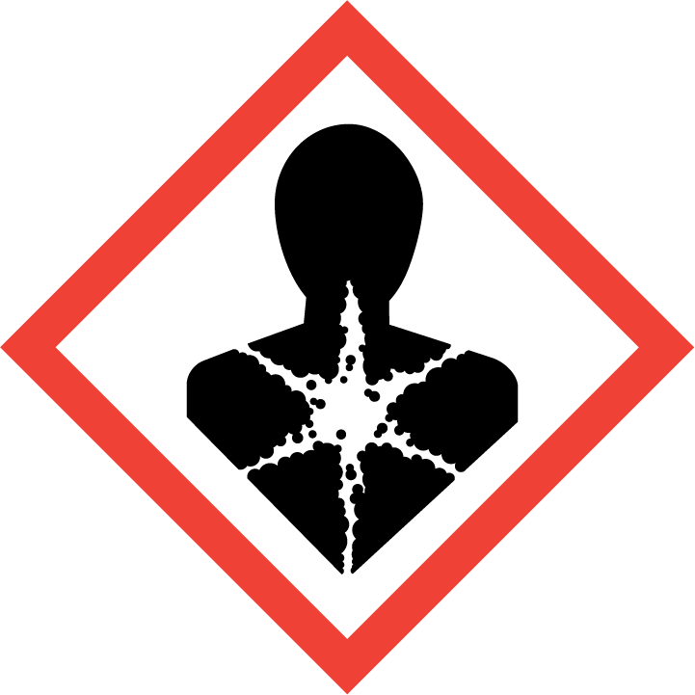
Flammable | Toxic | Harmful | Oxidising | Corrosive | Explosive | Harmful to the environment | Health Hazards i.e. respiratory sensitisation or carcinogenicity

SMOKING, EATING AND DRINKING ARE PROHIBITED IN THE WORK AREAS.
Information, Instruction and Training must be provided to all users. Young Persons, New or Expectant Mothers and other vulnerable groups must not use or be exposed to this product.

WORKPLACE EXPOSURE LIMITS (WEL’s)
N/A

ROUTE OF EXPOSURE
Skin |  | Eyes |  | Inhalation
Ingestion |  | Cuts/abrasions |  | Systemic

PERSONS AT RISK
User of product |  | Co workers |  | Members of the public

ROUTE OF EXPOSURE |   FIRST AID MEASURES
Eyes | In the event of eye contact, rinse the eyes for a sufficiently long time keeping the eyelids open, then consult an ophthalmologist without delay.
Skin | Wash with plenty of water. Remove contaminated clothing and wash prior to further wear
Inhalation | Ensure that there is a supply of fresh air.
Ingestion | Note that vomiting poses an aspiration hazard. After swallowing, rinse the mouth with plenty of water (only if the person is conscious) and seek immediate medical assistance.
In all cases of doubt, or if symptoms persist seek medical attention. Never give anything by mouth to an unconscious person. If unconscious, place in recovery position and seek medical advice.

PERSONAL PROTECTIVE EQUIPMENT
 |  |  | 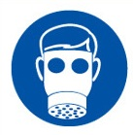 |  | 
YES/NO | YES/NO | YES/NO | YES/NO | YES/NO | YES/NO
Safety glasses or goggles to EN166 | Suitable long sleeved coveralls. |  |  | Welding Gloves

HANDLING | STORAGE | TRANSPORT | DISPOSAL
Do not pierce or burn, even after use. For professional users only | Keep containers tightly sealed. Storage class in accordance with technical rule TRGS 510: 2B (aerosol dispensers and lighters) | Keep aerosols upright. | Do not allow into sewers or ground water. Disposal in accordance with official regulations.

REQUIRED CONTROL MEASURES
- Read Risk Assessment 006 Storage, handling and Use of Flammable Liquids and Volatile Substances before using this product.
- Users to avoid contact with skin and eyes, and inhalation of vapours/ spray or mist arising from the application of this preparation – Use PPE.
- Only opened solvent containers should be kept at the bench.
- When not in use, opened solvent containers should be kept in the flammables cupboards, under the work benches.
- Surplus/ un-opened solvents must be kept in stores/ parts department.
- Ensure adequate welfare and washing facilities available and provide users with barrier and restorative creams.
- Ensure operatives are made aware of and understand the purpose of this assessment and SDS, plus any health implications of using the product.
- Ensure COSHH assessments with accompanying SDS are made available for all employees and users and for inspection and emergency purpose.
- Carry out personal exposure monitoring.
- Ensure adequate ventilation. In case of insufficient ventilation, wear suitable respiratory equipment.

FIRE PRECAUTIONS
Carbon dioxide (CO2), alcohol-resistant foam, dry powder.

ACCIDENTAL RELEASE/SPILLAGE PROCEDURES
Ensure sufficient ventilation. Do not breathe gas/smoke/vapours/spray. Avoid contact with the skin, eyes and clothing. Use personal protective equipment.

Environmental precautions:
Do not allow into sewers or ground water.

Methods and material for containment and cleaning up:
Absorb with a liquid-absorbing material (sand, kieselguhr, acid binder, universal binder). Handle the absorbed material according to the Disposal section.

MONITORING REQUIREMENTS AND HEALTH SURVEILLANCE
Health surveillance is in place for workers exposed to this product.

